**Using R Command Prompt**

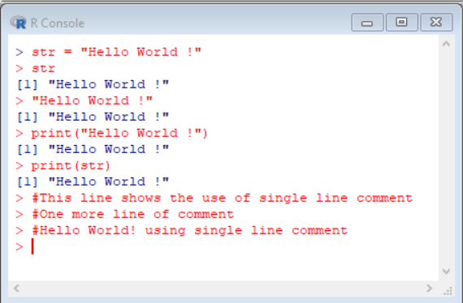

**Using Rscript in command line**

The contents of test.R:

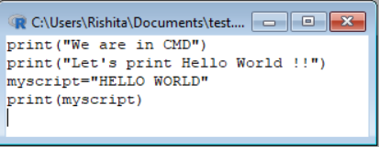

Executing test.R in Windows command Prompt:

